***Week 1 Of June: Frontend Development, Twitter Bot Development***

Task-1405 and Task-1409

Frontend is fully complete. And twitter bot to scrape data is working too.

#### Week 2 Of June: Backend Development, Serving ML Models, Classifying Data

Task-1406 and Task-1410

Backend is fully complete. NLP models with Embedding have been made and tested.

#### Week 3 Of June: Connection Of Frontend And Backend

Task-1407 and Task-1411

Connection and APIs are ready.

***Week 4 Of June: Code Documentation, Hosting***

Task-1407 and Task-1411

Deployment is Complete

**1**  **INTRODUCTION**

**1.1** **Overview**

Social Media platforms contain a huge repository of public and private opinion regarding a wide variety of subjects, expressed and spread continually by their users. Among those platforms, Twitter is gaining immense popularity.

We propose a system to computationally measure sentiments of live tweets by their users and sentiments regarding the government's decision on extending the lockdown.

The system consists of dashboard with various functionalities. Main dashboard has country-wise data visualization of the sentiments derived from the tweets, it has clickable map of India which shows state-wise data visualization as well. Live sentiment prediction of tweets is achieved using ML model.

Tweet fetching is dynamic to get up-to-date data automatically. Resources tab is available for COVID-19 related statistics and news.

**1.2** **Purpose**

* To provide one stop spot for sentiment analysis relating to COVID-19. Humans find comfort in knowing others feel the same way they do about a situation.
* To provide condensed feedback and public opinion to Government decisions.
* To provide region-wise data for public to form informed opinion,for local government bodies to take suitable actions.
* Real time sentiment prediction to use our ML model on unseen data, user just has to enter text.
* Data visualization tools to make sense of the data,to use that data to make any business related decisions.

**2** **LITERATURE SURVEY**

**2.1** **Existing Problem**

COVID-19 along with lockdown has turned into a lethal combination on mental health of a significant populus. Fear about uncertainity of future is one of the primary consequences of these unforeseeable circumstances. Government decision to impose lockdown to curb the increasing number of infected was necessary,the method of implementing it received mixed responses. To take further actions public input is required in a democracy. The question to conduct such a poll arises.

**2.2** **Proposed Solution**

We propose a system to computationally measure sentiments of live tweets by their users and sentiments regarding the government's decision on extending the lockdown.

This system will help us understand the impact of corona and its lockdown phase on the general population of India. We will collect a vast number of tweets and perform sentiment analysis on them which will be sorted through and displayed as per geographic regions. We plan to make a real time sentiment prediction on which user has to simply enter text and our deployed ML model will perform sentiment analysis on that text.

**3** **THEORITICAL ANALYSIS**

**3.1** **Block Diagram**

**3.2** **Hardware/Software Designing**

Our project is software based.

* [Twint](https://github.com/twintproject/twint) - Twitter scraping tool without the need of Twitter API
* [Node.js](https://nodejs.org/en/) - Node.js is a JavaScript runtime built on Chrome's V8 JS engine
* [Create a New React App](https://reactjs.org/docs/create-a-new-react-app.html) - Get started with React here
* [Material UI](https://material-ui.com/) - React components for faster and easier web development
* [Express.js](https://expressjs.com/) - A web application framework for Node.js
* [GraphQL](https://graphql.org/) - An open-source data query and manipulation language for APIs
* [Mongoose](https://mongoosejs.com/docs/) - An Object Data Modeling (ODM) library for MongoDB and Node
* [Tensorflow](https://www.tensorflow.org/) - Open source software library for Machine Learning frameworks
* [Keras](https://keras.io/) - Runs on top of tensorflow,designed to enable fast experimentation with deep neural networks
* [IBM API](https://www.ibm.com/in-en/cloud/api-connect) - Model will be hosted on IBM API
* [Docker](https://www.docker.com/) - Docker is a set of platform as a service products that uses OS-level virtualization to deliver software in packages called containers.
* [FastAPI](https://fastapi.tiangolo.com/) - FastAPI is a modern, fast (high-performance), web framework for building APIs with Python 3.6+ based on standard Python type hints.
* [Uvicorn](https://www.uvicorn.org/) - Uvicorn is a lightning-fast ASGI server, built on uvloop and httptools.

**4** **FLOWCHART**

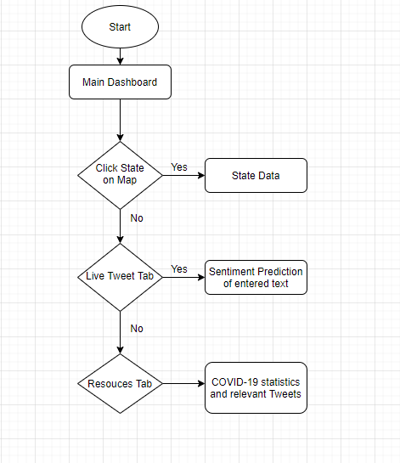

**5** **RESULT**

All-in-one dashboard to visualize emotions to coronavirus pandemic and government decisions related to it,based on Twitter data.

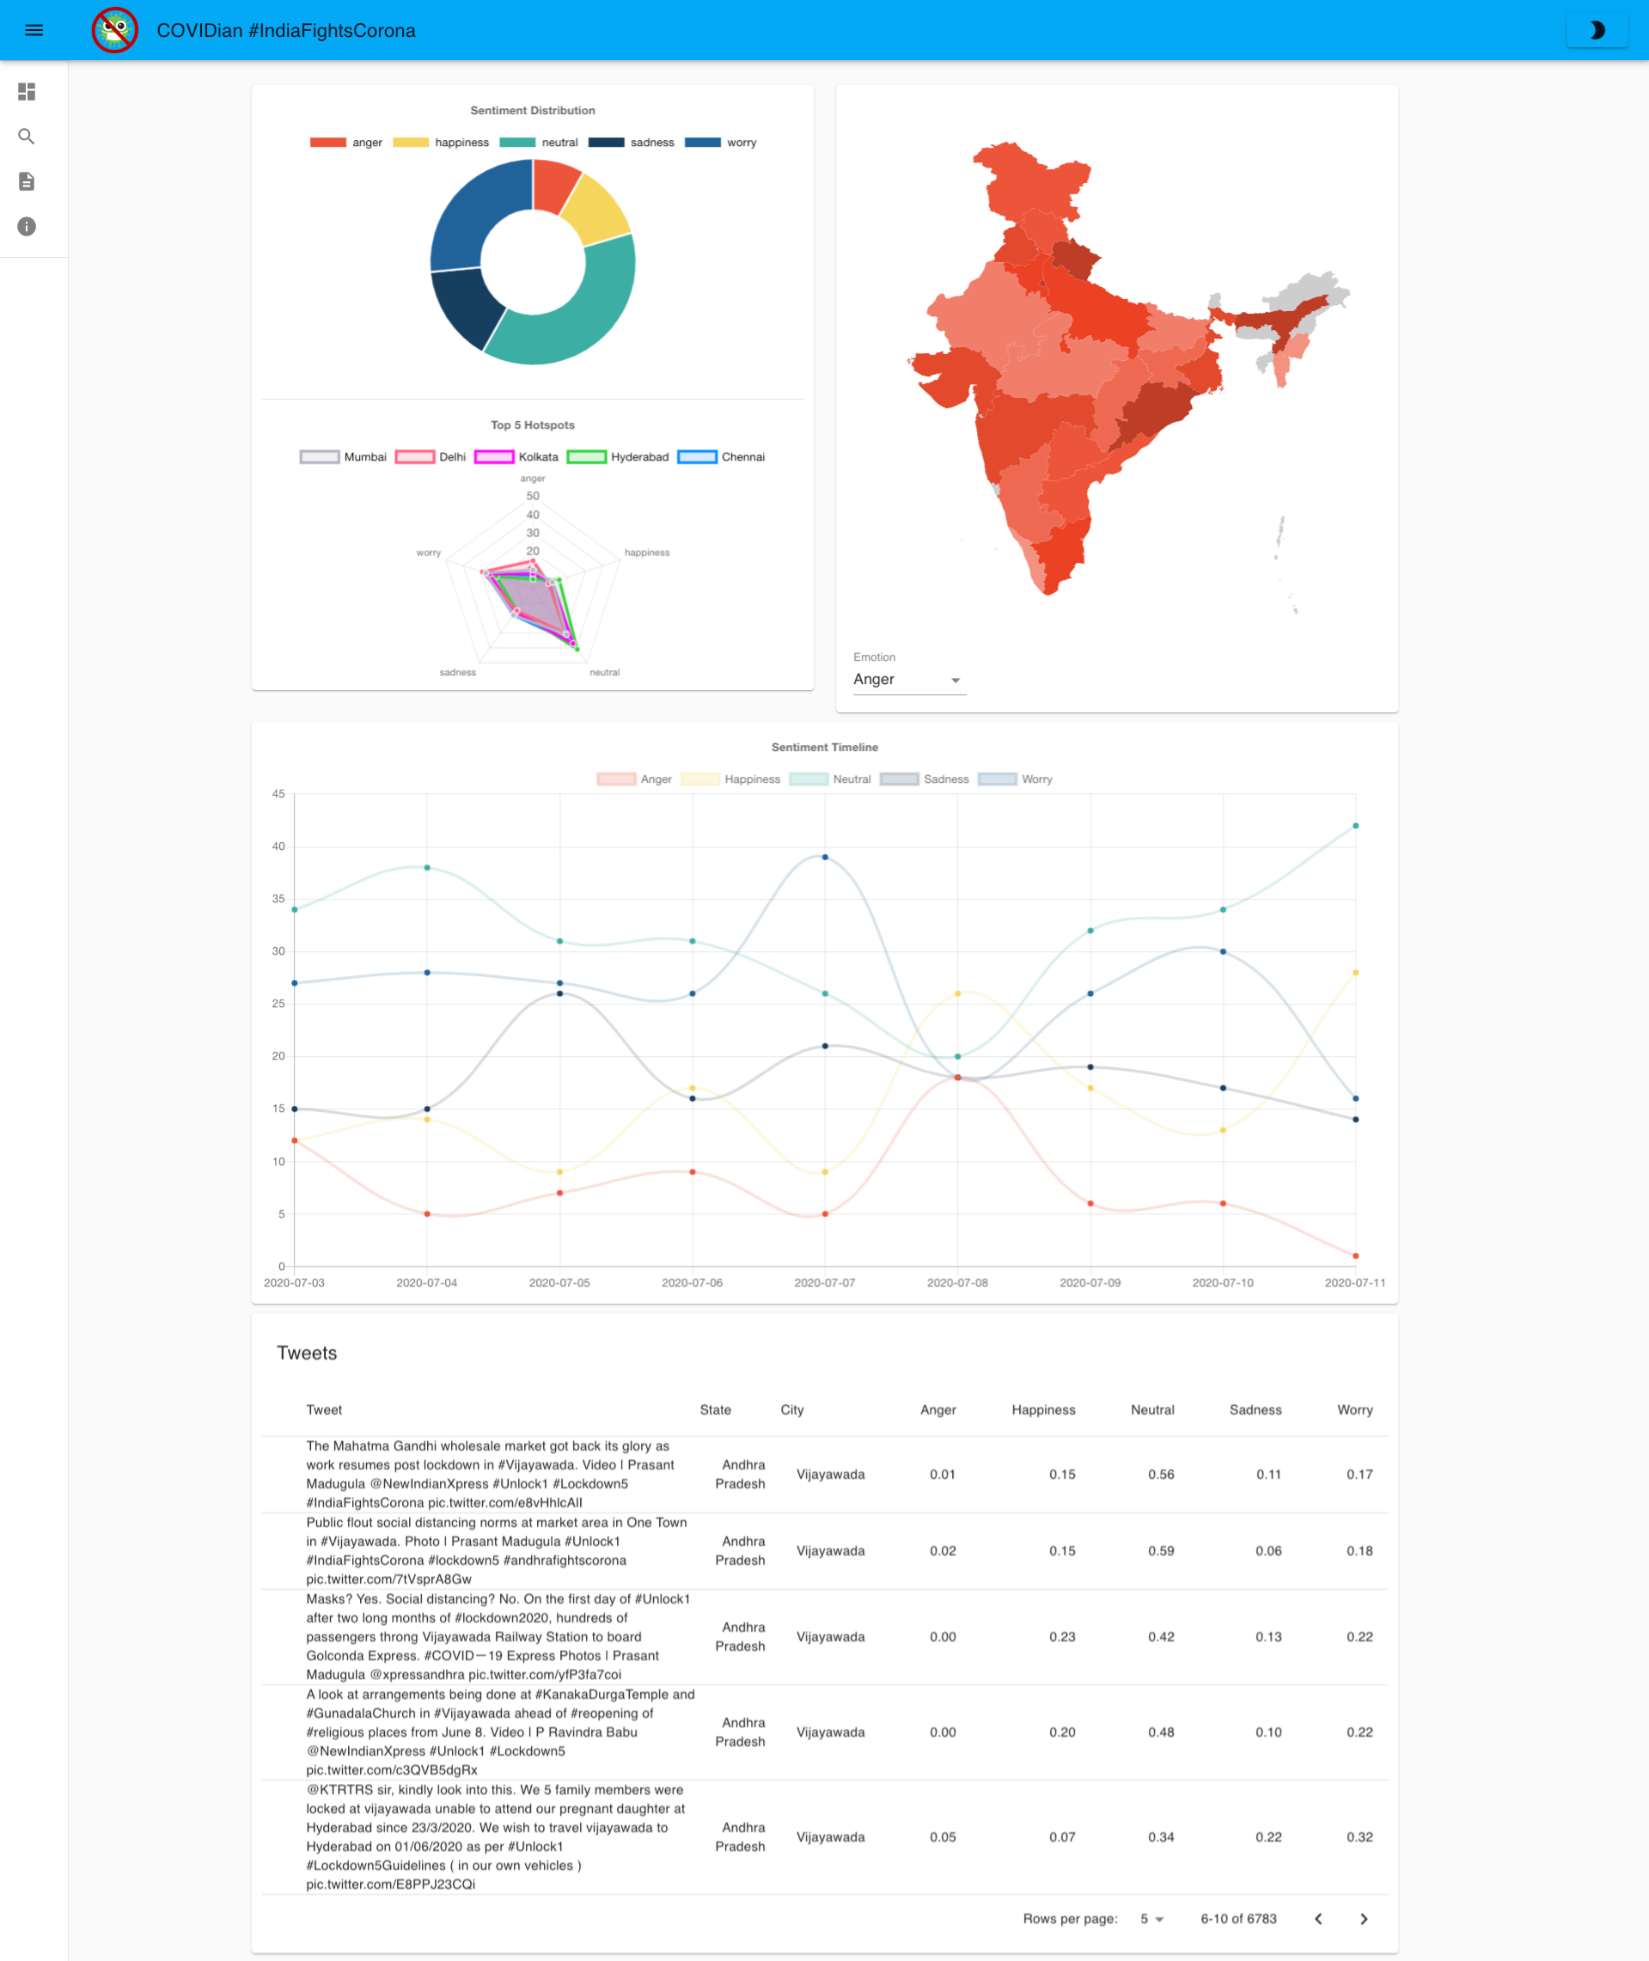

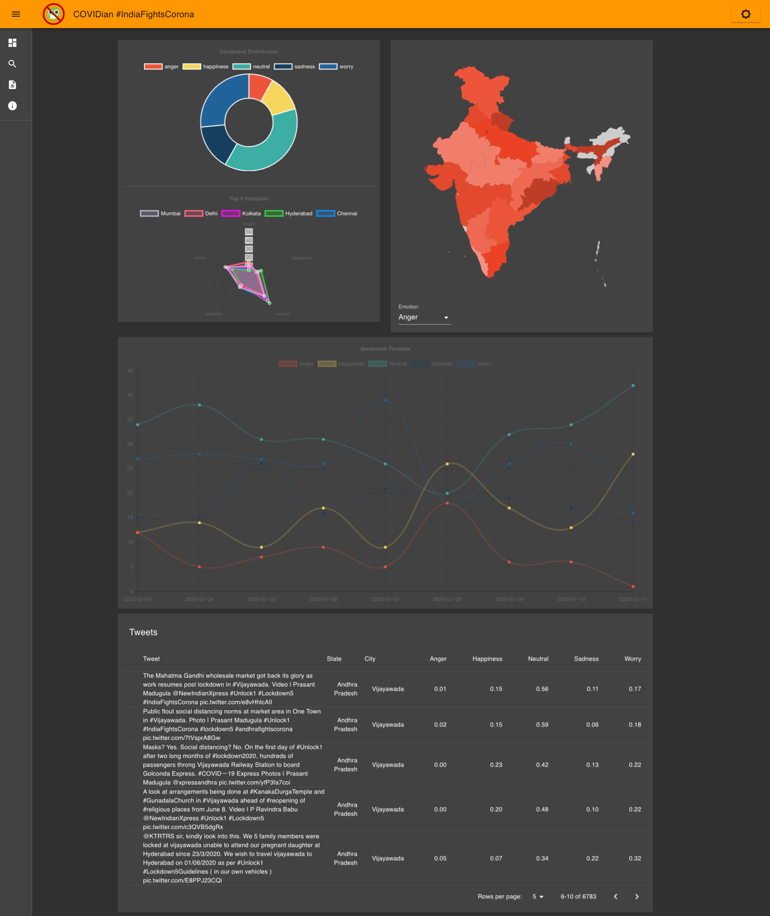

Hovering on any state gives general information about that state.

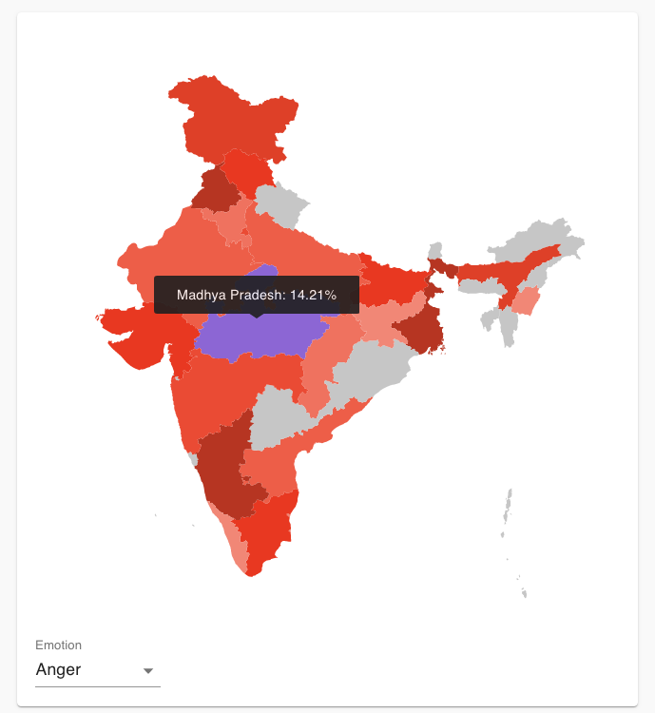

Clicking on any state gives state-specific information. Tweets specific to the state are also seen,with their *scores on emotions*.

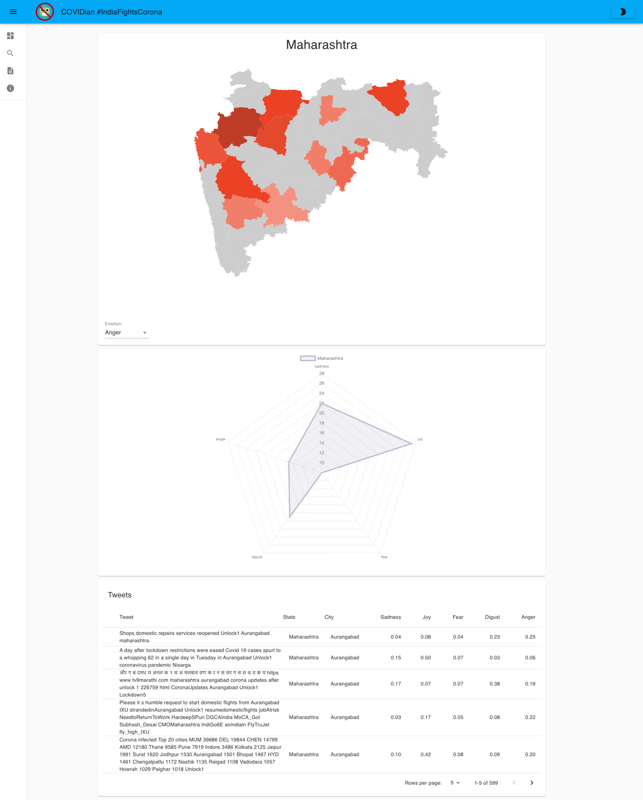

Enter a twitter username to get a list of the users tweets. You can perform live analysis of the tweet with our trained models.

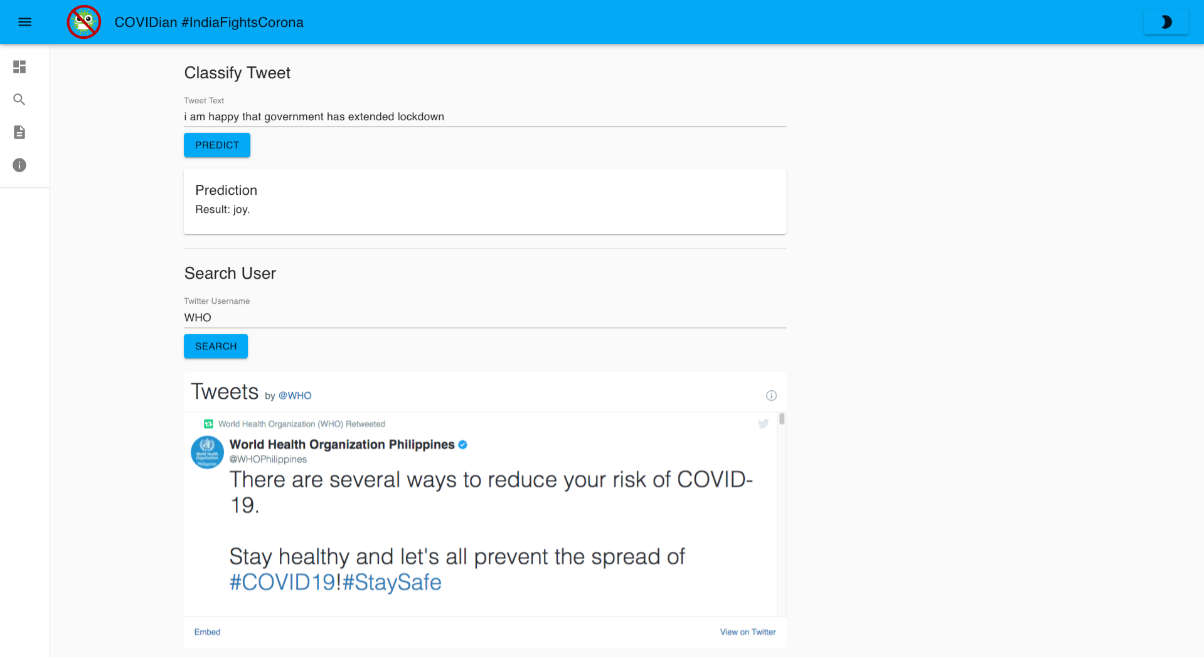

Latest updates on tweets and COVID statistics can be found here.

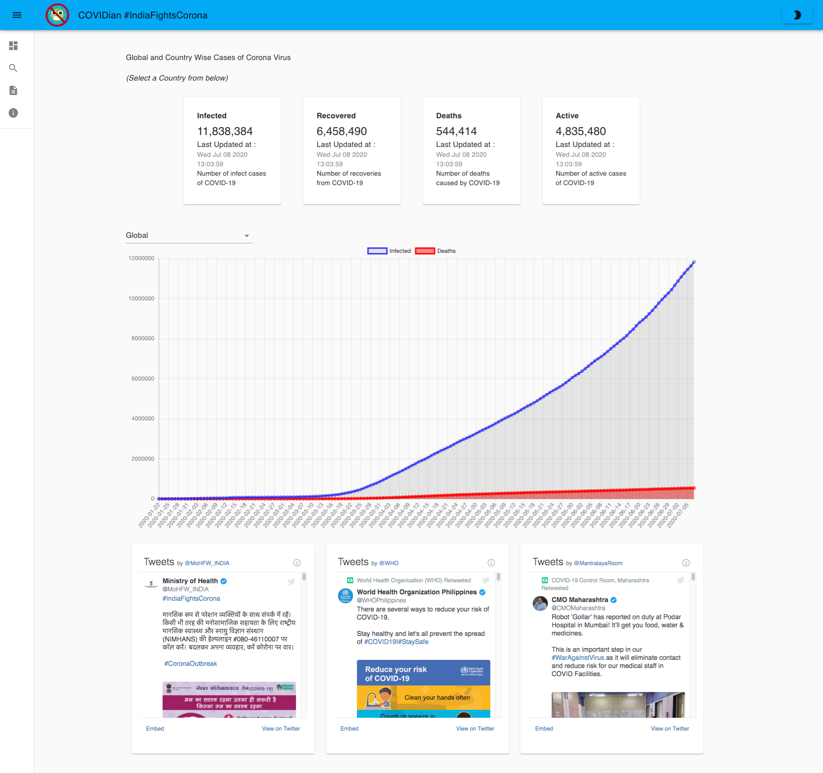

**6** **APPLICATIONS**

* Sentiment visualization on topics related to COVID-19. These may be used by Government as feedback and as an input for future decisions.
* Region wise data ensures feedback is localised and categorized as well, localized information is very useful.
* Companies can make business decisions based on the statistics available.
* Live tweet predictor, test our ML model on unseen tweets or texts.

**7** **CONCLUSION**

So we have successfully implemented Twitter Sentiment Analysis of COVID-19 Tweets Visualization Dashboard that displays geographic-wise dynamic tweet sentiment over entire India which can be broken down to individual state. Dashboard also displays real time sentiment graph to help understand the sentiment activity during past 10 days. User can also input their custom text or any tweets provided by twitter embedding on the same page. Our web application also provides live global COVID19 case statistics to help keep track of the number of cases.

**8** **FUTURE SCOPE**

* Sentiment tracker on any hashtag,especially for Government decisions. Local administrators can take actions based on public input (sentiment). Example, final year exam decision.
* Country wise expandable, thus making a global project that can be used for any country.
* Better ML models to further increase accuracy.
* Twitter bot to provide our statistics on Twitter timeline itself.

**9** **BIBILIOGRAPHY**

**APPENDIX**

**A. SOURCE CODE**

<https://github.com/SmartPracticeschool/SBSPS-Challenge-1800-Sentiment-Analysis-of-COVID-19-Tweets-Visualization-Dashboard>